PLAYFAIR CIPHER

PROGRAM :

key=input("Enter key:")

key=key.replace(" ", "")

key=key.upper()

def matrix(x,y,initial):

return [[initial for i in range(x)] for j in range(y)]

result=list()

for c in key: #storing key

if c not in result:

if c=='J':

result.append('I')

else:

result.append(c)

flag=0

for i in range(65,91): #storing other character

if chr(i) not in result:

if i==73 and chr(74) not in result:

result.append("I")

flag=1

elif flag==0 and i==73 or i==74:

pass

else:

result.append(chr(i))

k=0

my_matrix=matrix(5,5,0) #initialize matrix

for i in range(0,5): #making matrix

for j in range(0,5):

my_matrix[i][j]=result[k]

k+=1

def locindex(c): #get location of each character

loc=list()

if c=='J':

c='I'

for i ,j in enumerate(my_matrix):

for k,l in enumerate(j):

if c==l:

loc.append(i)

loc.append(k)

return loc

def encrypt(): #Encryption

msg=str(input("Enter plaintext:"))

msg=msg.upper()

msg=msg.replace(" ", "")

i=0

for s in range(0,len(msg)+1,2):

if s<len(msg)-1:

if msg[s]==msg[s+1]:

msg=msg[:s+1]+'X'+msg[s+1:]

if len(msg)%2!=0:

msg=msg[:]+'X'

print("Cipher Text:",end=' ')

while i<len(msg):

loc=list()

loc=locindex(msg[i])

loc1=list()

loc1=locindex(msg[i+1])

if loc[1]==loc1[1]:

print("{}{}".format(my_matrix[(loc[0]+1)%5][loc[1]],my_matrix[(loc1[0]+1)%5][loc1[1]]),end=' ')

elif loc[0]==loc1[0]:

print("{}{}".format(my_matrix[loc[0]][(loc[1]+1)%5],my_matrix[loc1[0]][(loc1[1]+1)%5]),end=' ')

else:

print("{}{}".format(my_matrix[loc[0]][loc1[1]],my_matrix[loc1[0]][loc[1]]),end=' ')

i=i+2

def decrypt(): #decryption

msg=str(input("ENTER CIPHER TEXT:"))

msg=msg.upper()

msg=msg.replace(" ", "")

print("PLAIN TEXT:",end=' ')

i=0

while i<len(msg):

loc=list()

loc=locindex(msg[i])

loc1=list()

loc1=locindex(msg[i+1])

if loc[1]==loc1[1]:

print("{}{}".format(my_matrix[(loc[0]-1)%5][loc[1]],my_matrix[(loc1[0]-1)%5][loc1[1]]),end=' ')

elif loc[0]==loc1[0]:

print("{}{}".format(my_matrix[loc[0]][(loc[1]-1)%5],my_matrix[loc1[0]][(loc1[1]-1)%5]),end=' ')

else:

print("{}{}".format(my_matrix[loc[0]][loc1[1]],my_matrix[loc1[0]][loc[1]]),end=' ')

i=i+2

while(1):

print("\n 1.Encryption \n 2.Decryption: \n 3.Exit")

choice=int(input("Enter your choice:"))

if choice==1:

encrypt()

elif choice==2:

decrypt()

elif choice==3:

exit()

else:

print("Choose correct choice")

OUTPUT :

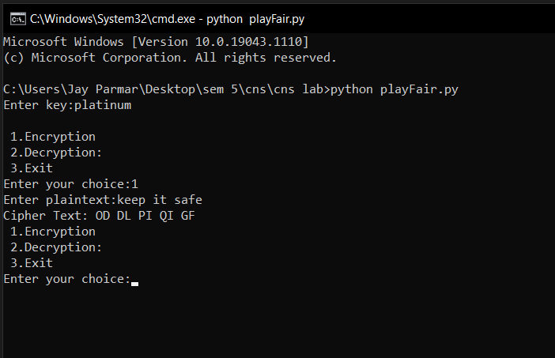

VIGNERE CIPHER

PROGRAM :

def generateKey(string, key):

key = list(key)

if len(string) == len(key):

return(key)

else:

for i in range(len(string) -

len(key)):

key.append(key[i % len(key)])

return("". join(key))

def cipherText(string, key):

cipher_text = []

for i in range(len(string)):

x = (ord(string[i]) +

ord(key[i])) % 26

x += ord('A')

cipher_text.append(chr(x))

return("" . join(cipher_text))

if __name__ == "__main__":

string = input("Enter a plaintext:")

keyword = input("Enter a keyword:")

key = generateKey(string, keyword)

cipher_text = cipherText(string,key)

print("Ciphertext :", cipher_text)

OUTPUT :

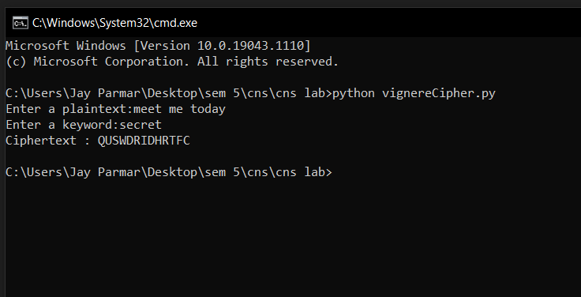

CONCLUSION : Hence we have learned and implemented cryptanalysis or decoding playfair, vignere cipher using python.